Marking Doc

## Task 1: Waiter/waitress view

### Responsive design:

|  |  |
| --- | --- |
| Mobile | Tablet plus |
| This is the list of orders each table has | |
|  |  |
| The mobile view hides the est wait time and time waiting in the drop down, instead of the main bar. | Spreads out the data in rows to make it easy to scan through and find an order. Then click ‘open’ to find out more details |
| This is the menu, where the waiter can go through the list of categories and then pick a item from that list to add to a order | |
|  |  |
| Mergs 1 of the 3 columns into a screen, having the arrows at the bottom to go back and forth | It has the catagrees on the left, items in the middle and then all the items selected on the right, making it easy for tablets and bigger to manage all 3 at once. Catagress is also an additional part that makes it much easier to find items in the menu. |

### Testing Environments

We did testing on 7 different environments. Mainly mobile and tablets as it will be used most on those devices. Can be found in the ‘Browser Compatibility Test.doc’.

## Task 2: Kitchen + Counter view

### Functionality:

|  |  |
| --- | --- |
| Mobile | Tablet plus |
| This is the list of orders the cooks need to cook. The additional info button top right will show or hide the order number and wait time | |
|  |  |
| The counter view, has | |
|  |  |

### Testing Environments

We did testing lots of different environments. Mainly mobile and tablets as it will be used most on those devices. Can be found in the ‘Browser Compatibility Test.doc’.

## Task 3: Admin view

### Functionality:

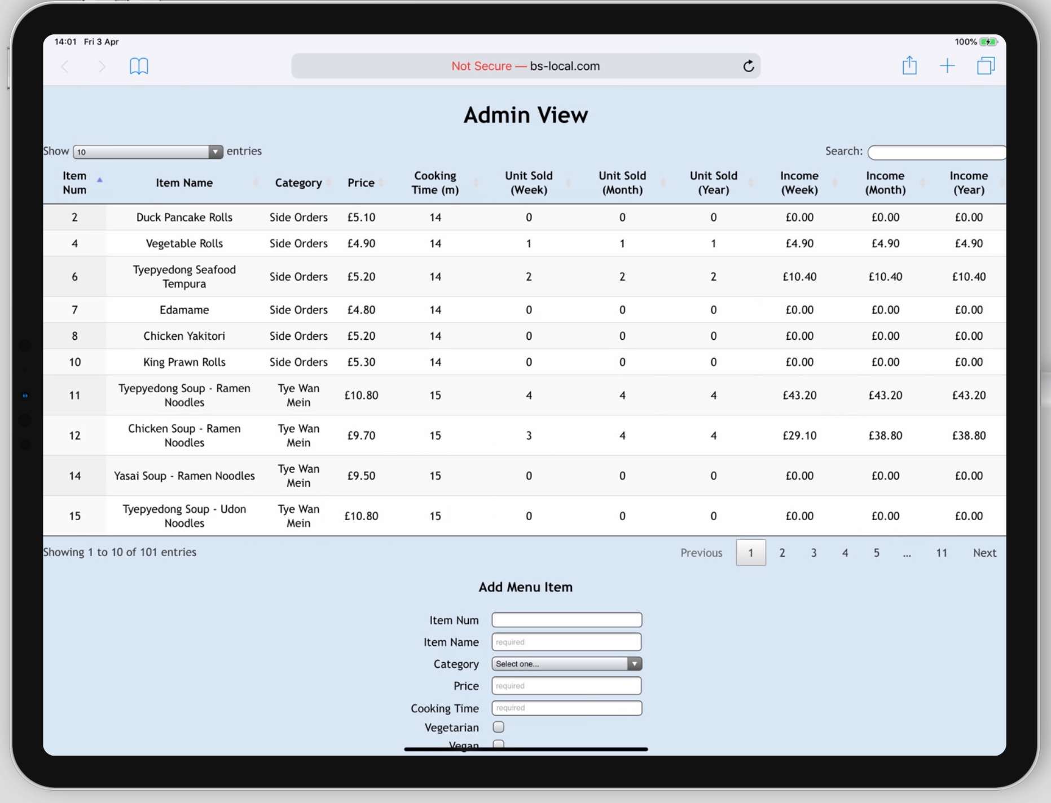

There is an add menu item section at the bottom that lets the admin update the item list and manage the categories.

**Additional tasks**

In addition to this there are lots of extra features such as data on how much items are sold, which could be used to make decisions about what items are on the menu and would be very useful for deliveries.



We added a admin login, the password by default is ‘password’ but can be edited in admin_password.txt

### Testing Environments

We did testing lots of different environments. We did testing on all devices mobile, tablets and desktop as the admin view may be used out of the restaurant as well. Can be found in the ‘Browser Compatibility Test.doc’.

## Task 4:

4.1 summary report:

|  |  |
| --- | --- |
| We added a button that shows the weekly profits, giving statistics about the week’s orders. Included a graph and category profits. | |
|  | |

4.2 use of timestamps:

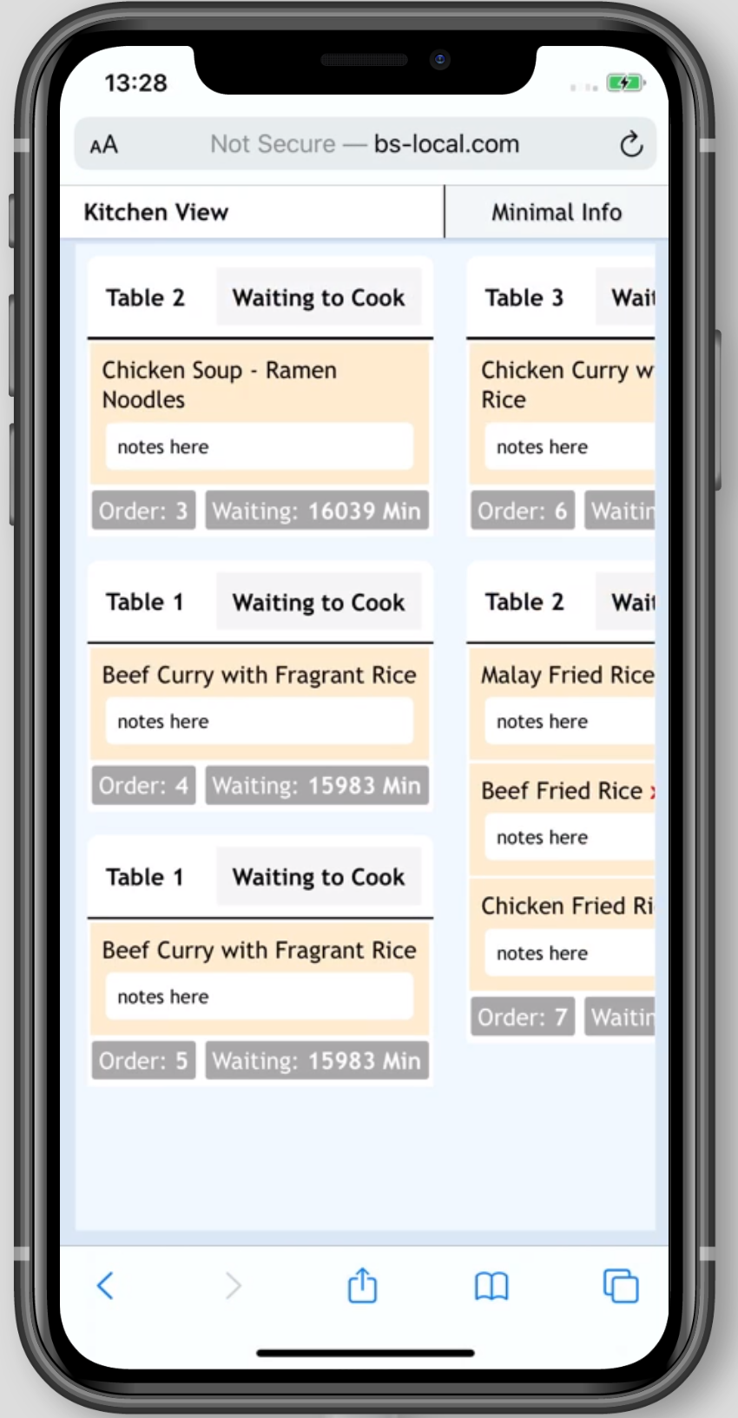

Click the top right button (additional info/minimal info) will show or hide the order number and customer wait time

4.3 bill print

On the counter view there is a button to print bill and this will reformat the page to lay it out in bill structure.

4.4 our ideas:

We added a lot of our ideas that we thought could make the whole system work better. We added the estimated wait time to each order, helping the waiter keep the table informed to how long they might expect their food to take, as well as their waiting time so they know which tables have been waiting the longest. As well as that we added a discount section where the waiter can discount their order, for example if there was a long wait time they might discount them 10%.

Another edit which appears on most of the views is notes which can be added to every item, for example they might want the dish without the sauce or they might want it well done. The waiter can add those special requests to the order item which will be sent to the kitchen.

